

IMPROVING UTILISATION OF INFRASTRUCTURE AS A SERVICE

A PROJECT REPORT

Submitted by

MADHUSUDHANAN.R (30908205020)
GOVINDARAJAN.G (30908205010)
NIRMAL YOGARAJ.K(30908205026)

in partial fulfillment for the award of the degree

of

BACHELOR OF ENGINEERING

in

INFORMATION TECHNOLOGY

MEENAKSHI SUNDARARAJAN ENGINEERING COLLEGE,
KODAMBAKKAM, CHENNAI – 600 024

ANNA UNIVERSITY :: CHENNAI 600 025
April 2012

ANNA UNIVERSITY : CHENNAI 600 025

BONAFIDE CERTIFICATE

Certified that this project report “IMPROVING UTILISATION OF INFRASTRUCTURE AS A SERVICE” is the bonafide work of “MADHUSUDHANAN.R (30908205020), GOVINDARAJAN.G (30908205010) and NIRMAL YOGARAJ.K (30908205026)” , who carried out the project work under my supervision.

SIGNATURE SIGNATURE
Mrs. A. Kanimozhi, M.E., (Ph.D) Mrs. E.Bhavani, M.E.
HEAD OF THE DEPARTMENT SUPERVISOR
Information Technology Information Technology
Meenakshi Sundararajan Engineering Meenakshi Sundararajan Engineering
College, College,
No. 363, Arcot Road, Kodambakkam, No. 363, Arcot Road, Kodambakkam,
Chennai – 600 024 Chennai – 600 024

Submitted for the project viva voce of Bachelor of Engineering in Information Technology held on _________________.

INTERNAL EXAMINER EXTERNAL EXAMINER

ACKNOWLEDGEMENT

We take this opportunity to thank Prof. K.S. Babai B.Sc., B.E., M.S.,FIE.,
(Principal, Meenakshi Sundararajan Engineering College, Chennai-24) for permitting us to use all the facilities to carry out this project work and for the continuous motivation in and around the student circle.

We would like to thank Mrs. A. Kanimozhi, M.E., (Ph.D), Head of the Department of Information Technology, Meenakshi Sundararajan College, who helped us, time and again, to bring the best out of us.

We would also like to place on record, our sincere gratitude to our internal guide
Mrs. E. Bhavani , Lecturer, Meenakshi Sundararajan Engineering College, for her constant support and guidance in the successful completion of the project.

We sincerely thank Mr Jasper Wessly (Technical Head, HCL Technologies) for his constant encouragement and timely help that motivated us to head in the right direction and complete the project.

We would also like to thank, all teaching and non-teaching staff members of our department, for their support during the course of the project.

Above all, we would like to thank the Almighty for His blessings.

TABLE OF CONTENTS

CHAPTER NO. TITLE PAGE NO.

ACKNOWLEDGEMENT

LIST OF FIGURES

LIST OF ABBREVIATIONS

ABSTRACT
1. INTRODUCTION

1.1 EXISTING SYSTEM
1.2 PROPOSED SYSTEM

2. LITERATURE REVIEW

3. SYSTEM STUDY 6

3.1 On Demand Access
3.2 Opportunistic User
3.3 Fraud Detection System
3.4 Automatic Management Service
3.5 Back Fill Virtual Machine Implementation

4. REQUIREMENT SPECIFICATION

4.1 Hardware Specification
4.2 Software Specification

5. LANGUAGE DESCRIPTION

6. SYSTEM DESIGN AND DEVELOPMENT

6.1 Use Case Diagram
6.2 Class Diagram
6.3 Sequence Diagram
6.4 Activity Diagram

7. TESTING

7.1 System Testing
7.2 Unit Testing
7.3 Functional Testing
7.4 Integration Testing
7.5 White Box Testing
7.6 Black Box Testing

8. CODING AND IMPLEMENTATION

9. CONCLUSION AND FUTURE ENHANCEMENT

10. REFERENCES
LIST OF FIGURES

FIGURE NO | FIGURE NAME | PAGE NO
1 | Cloud Cycle Depiction
2 | Iaas Cloud Representation
3 | Backfill Deployment
4 | Java Translation
5 | Tomcat Web Server
6 | Use case Diagram
7 | Class Diagram
8 | Sequence Diagram
9 | Activity Diagram
10 | Functional Testing
11 | Integration Testing
12 | Black Box Testing

ABBREVIATIONS

IaaS Infrastructure – as – a – Service

SaaS Software-as-a-Service

PaaS Platform-as-a-Service

HTC High Throughput Computing

VM Virtual Machine

VMM Virtual Machine Monitor

ABSTRACT

A key advantage of Infrastructure-as-a-Service (IaaS) clouds is providing users on-demand access to resources. However, to provide on-demand access, cloud providers must either significantly overprovision their infrastructure (and pay a high price for operating resources with low utilization) or reject a large proportion of user requests (in which case the access is no longer on-demand). At the same time, not all users require truly on-demand access to resources. Many applications and workflows are designed for recoverable systems where interruptions in service are expected. The proposal is that a cloud infrastructure combining on-demand allocation of resources with opportunistic provisioning of cycles from idle cloud nodes to other processes by deploying backfill Virtual Machines (VMs). There exists a shared infrastructure between IaaS cloud providers and an HTC job management system can be highly beneficial to both the IaaS cloud provider and HTC users by increasing the utilization of the cloud infrastructure (thereby decreasing the overall cost) and contributing cycles that would otherwise be idle to processing HTC jobs. To deploy their applications, cloud users then install operating system images on the machines as well as their application software. In this model, it is the cloud user who is responsible for patching and maintaining the operating systems and application software.

CHAPTER 1

INTRODUCTION

1.1 ABOUT THE PROJECT

In this most basic cloud service model, cloud providers offer computers – as physical or more often as virtual machines –, raw (block) storage, firewalls, load balancers, and networks. IaaS providers supply these resources on demand from their large pools installed in data centers. Local area networks including IP addresses are part of the offer. For the wide area connectivity, the Internet can be used or - in carrier clouds - dedicated virtual private networks can be configured.

To deploy their applications, cloud users then install operating system images on the machines as well as their application software. In this model, it is the cloud user who is responsible for patching and maintaining the operating systems and application software. Cloud providers typically bill IaaS services on a utility computing basis, that is, cost will reflect the amount of resources allocated and consumed.
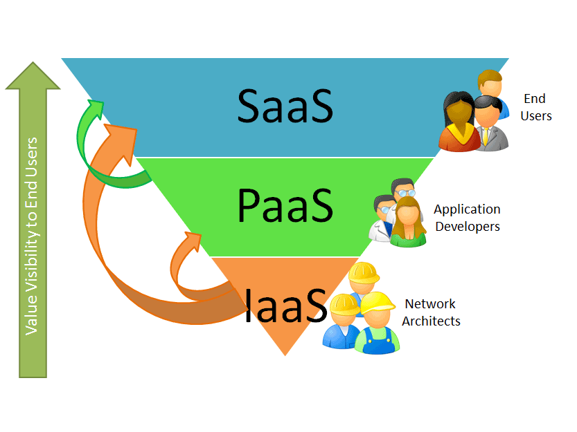
Fig 1.1 Cloud Cycle Depiction
This is the base layer of the cloud stack. It serves as a foundation for the other two layers, for their execution. The keyword behind this stack is Virtualization. The IaaS provider supplies the whole cloud infrastructure viz. servers, routers, hardware based load-balancing, firewalls, storage and other network equipment. The customer buys these resources as a service on an as needed basis. The billing is on hourly or monthly basis. You pay only for the resources your actually consume.

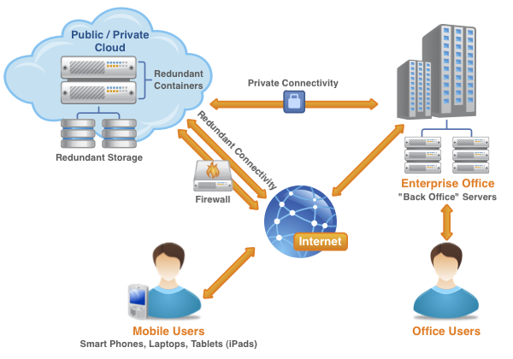

Fig 1.2 IaaS Cloud Representation

This is unlike the traditional services where you pay a fixed amount even if you don’t use the resources, or don’t have enough clients to consume the preconfigured resources. In cloud computing, (IaaS), you pay less if you have a lower customer base and vice-versa. Cloud is elastic in nature where you can control the number of resources you use at any given point in time. The cloud infrastructure is operated solely for an organization. It may be managed by the organization or a third party and may exist on premise or off premise.

1.2 EXISTING SYSTEM

- In previous projects, it is impossible to know whether the terms of the SLA are being met without monitoring and measuring the performance of the service.

- Service Level Management is how that performance information is gathered and handled. Measurements of the service are based on the Service Level Objectives in the SLA.

- A cloud provider uses Service Level Management to make decisions about its infrastructure. An increasing number of research infrastructures must handle large data sets and must provide significant compute power.

- The present resource providers must agree on a common interface (virtual machine).The virtual machine mapping must be implemented where the hardware provider must also maintain the runtime environment.

- Compatibility is shifted to the virtual machine where the users are
responsible for application.

1.3 PROPOSED SYSTEM

- Infrastructure-as-a-Service (IaaS) cloud computing has emerged as an attractive alternative to the acquisition and management of physical resources.

- The on demand provisioning it supports allows users to elastically expand and contract the resource base available to them based on an immediate need – a pattern that enables a quick turnaround time when dealing with emergencies, working towards deadlines, or growing an institutional resource base.

- We demonstrate that a shared infrastructure between IaaS cloud providers and an HTC job management system can be highly beneficial to both the IaaS cloud provider and HTC users by increasing the utilization of the cloud infrastructure (thereby decreasing the overall cost) and contributing cycles that would otherwise be idle to processing HTC jobs.

- IaaS cloud administrators must consider a variety of different backfill configurations when deploying a backfill solution on an IaaS cloud. The configuration is influenced by the characteristics of the underlying physical IaaS resources, the users of on-demand leases, and the users of preemptible leases.

CHAPTER 2
LITERATURE REVIEW

Literature survey is the most important step in software development process. Before developing the tool it is necessary to determine the time factor, economy n company strength. Once these things r satisfied, ten next steps are to determine which operating system and language can be used for developing the tool. Once the programmers start building the tool the programmers need lot of external support. This support can be obtained from senior programmers, from book or from websites. Before building the system the above considerations are taken into account for developing the proposed system.

However, such private cloud installations also face a utilization problem. In order to ensure on-demand availability a provider needs to overprovision: keep a large proportion of nodes idle so that they can be used to satisfy an on-demand
request, which could come at any time. The need to keep all these nodes idle leads to low utilization. The only way to improve it is to keep fewer nodes idle. But this means
potentially rejecting a higher proportion of requests – to a point at which a provider no longer provides on-demand computing. This situation is particularly hard to accept in the world of scientific computing where the use of batch schedulers typically ensures high utilization and thus much better resource amortization. Thus, potential low utilization constitutes a significant potential obstacle to the adoption of cloud computing in the scientific world.
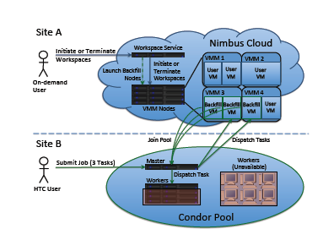
Fig 2.1 Backfill Deployment Algorithm

In our work we extend the Nimbus to deploy backfill VMs on idle Virtual Machine Monitor (VMM) nodes. Nimbus is an open source toolkit for deploying IaaS clouds, designed with extensibility in mind, which makes it particularly suitable for projects such as the one described here.To illustrate how the system works, we configure the backfill VMs as Condor workers that integrate with a Condor pool to process HTC jobs. We evaluate the ability of the system to increase utilization of the IaaS cloud infrastructure without sacrificing the ability of the IaaS cloud to provision resources
on-demand.

For the evaluation we define the following metrics:

• Utilization is the percentage of user cycles consumed by CPU cores on the VMM nodes in the IaaS cloud that are either running an HTC job or running an on-demand user VM. Because backfill launches VMs on any idle VMM node, regardless
of the presence of HTC jobs, it is possible for the entire IaaS infrastructure to be running backfill VMs on all VMM nodes but still have 0% utilization. For our evaluation backfill VMs must be running Condor jobs for them to contribute to
the overall utilization of the infrastructure.

• First queued time is the amount of time that elapses between the time when a Condor job is submitted and when it first begins executing.

• Last queued time is the amount of time that elapses between the time the Condor job is first submitted and the time the Condor job finally begins executing for the last time before completing successfully. We note that it is possible for backfill VMs to be terminated by the deployment of on demand user VMs, preempting Condor jobs
executing in backfill VMs, and thus requiring their resubmission. While this may happen to a Condor job any number of times, it is presumed that the job will eventually be able to execute successfully to completion.

• User VM Service response time is the amount of time it takes the Nimbus service to respond to an on-demand user request, i.e., the time between when the service first receives the request and the time it determines whether a VM will be launched
or that the request will be rejected. This time does not include the amount of time that it takes to actually boot the on-demand user VM or propagate the VM image, only the amount of time it takes the service to determine whether or not the request will
be handled. If backfill is enabled and backfill VMs need to be terminated to deploy an on-demand user VM, the user VM service response time will include the necessary time to terminate backfill VMs.

CHAPTER 3

SYSTEM STUDY

MODULES:

- On Demand Access
- Opportunistic User
- Fraud Detection Service
- Automation Management Service
- Back Fill Virtual Machine implementation.

3.1 ON DEMAND ACCESS:

We extend the open source cloud computing toolkit, which provides on-demand access to resources (in the form of VMs), to support the deployment of preemptible leases on idle cloud nodes, also referred to as backfill. We make a
number of simplifying assumptions in our current implementation. First, the Nimbus administrator must configure backfill. On-demand cloud users cannot elect to
deploy backfill VMs. Second, the current implementation is capable of using only a single backfill VM image per VMM node.

Different backfill VM images could be deployed on different VMM nodes, allowing multiple backfill VM images to operate within the same IaaS cloud, each performing different functions.Unless the user specifies the max number of backfill instances, backfill automatically attempts to deploy as many backfill VMs as possible when it is enabled. Initially, we support two termination policies for selecting backfill VMs for termination in order to fulfill an on-demand lease.

3.2 OPPORTUNISTIC USER

On-demand, non-preemptible and flexible leases give a user access to a resource within interactive time of making the request and make the resource available for an agreed-upon period of time. The user can deploy
any VM compatible with the system.

Opportunistic, preemptible and pre-set leases give a user access to a resource at an indeterminate time and make the resource available to the user for an indeterminate amount of time. Further, this resource is pre-defined for the user by the cloud administrator, i.e. the user cannot provide his or her own VM.

3.3 FRAUD DETECTION SERVICE

In this module our goal is to detect when the distributor’s sensitive data has been leaked by agents, and if possible to identify the agent that leaked the data. Perturbation is a very useful technique where the data is modified and made “less sensitive” before being handed to agents. We develop unobtrusive techniques for detecting leakage of a set of objects or records.

3.4 AUTOMATION MANAGEMENT SERVICE

This system typically enables the top level management to keep track of the status of the projects under their control. Some of the critical activities that can be performed with this system are monitoring the completion status of project documents, to alert PL’s indicating the documents completion dates. HR allocates projects to GL, PL of a particular client with project code, project name and start date of the particular project. The system keeps tracks of the documents that have to be completed within a particular duration. PL gets the intimation before two days of each documents completion date. This notifies the PL to complete his schedule on time. The system for automating the project process, which involves three phases. Project Initiation Phase, Regular Mode. Project Windup . The system helps the HR, GL, PM, PL, TL, TM, GM to view the status of the project and helps in tracking information about the project.

3.5 BACKFILL VIRTUAL MACHINE IMPLEMENTATION

In the context of IaaS clouds, backfill VMs are generic VMs deployed on IaaS resources using a preemptible lease that may be configured to perform any function. Backfill VMs have two major constraints. First, backfill VMs may be terminated
suddenly in order to free up space for the IaaS cloud manager to service an on-demand lease. Second, because of the unpredictable timing of on-demand leases (from any number of unique users), a variable number of backfill VMs may be
available at any given time. Thus, we assume that applications executing inside backfill VMs are designed to handle environments that contain a variable number of workers that may join or leave the system at any time.

Certain applications are not well suited for these volatile environments, for example, parallel applications that require all processes to be present for the duration of the application’s execution and lack checkpoint/restart capabilities. An example
of a system that is well-suited for backfill VMs are High Throughput Computing (HTC) workloads In addition, terminating individual HTC jobs in the middle of execution and requeuing them for later execution is an acceptable action as long as the system is eventually able to process the workload.

CHAPTER 4

REQUIREMENT SPECIFICATION

A software requirements specification (SRS) – a requirements specification for a software system – is a complete description of the behavior of a system to be developed. It includes a set of use cases that describe all the interactions the users will have with the software. In addition to use cases, the SRS also contains non-functional requirements which impose constraints on the design or implementation

4.1 HARDWARE SPECIFICATION

- Processor : Intel(r) Pentium(r) M
- RAM : .99 GB
- Monitor : 1024 x 496
- Speed : 1.1 GHz

4.2 SOFTWARE SPECIFICATION

- Windows Operating System 2000 and above
- Visual Studio 2010
- MySQL
- Tomcat5.0/6.X
- NetBeans 7.1.1 or above

CHAPTER 5

LANGUAGE DESCRIPTION

5.1 Java Technology
Java technology is both a programming language and a platform.

5.1.1 The Java Programming Language

The Java programming language is a high-level language that can be characterized by all of the following buzzwords:
    - Simple
    - Architecture neutral
    - Object oriented
    - Portable
    - Distributed
    - High performance
    - Interpreted
    - Multithreaded
    - Robust
    - Dynamic
    - Secure

With most programming languages, you either compile or interpret a program so that you can run it on your computer. The Java programming language is unusual in that a program is both compiled and interpreted. With the compiler, first you translate a program into an intermediate language called Java byte codes —the platform-independent codes interpreted by the interpreter on the Java platform. The interpreter parses and runs each Java byte code instruction on the computer. Compilation happens just once; interpretation occurs each time the program is executed. The following figure illustrates how this works.

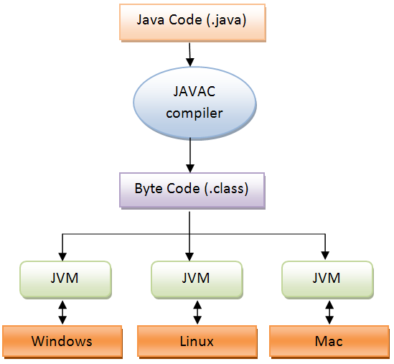
Fig 5.1 Java Platform Runtime Execution

You can think of Java byte codes as the machine code instructions for the Java Virtual Machine (Java VM). Every Java interpreter, whether it’s a development tool or a Web browser that can run applets, is an implementation of the Java VM. Java byte codes help make “write once, run anywhere” possible. You can compile your program into byte codes on any platform that has a Java compiler. The byte codes can then be run on any implementation of the Java VM. That means that as long as a computer has a Java VM, the same program written in the Java programming language can run on Windows 2000, a Solaris workstation, or on an iMac.

5.1.2 The Java Platform
A platform is the hardware or software environment in which a program runs. We’ve already mentioned some of the most popular platforms like Windows 2000, Linux, Solaris, and MacOS. Most platforms can be described as a combination of the operating system and hardware. The Java platform differs from most other platforms in that it’s a software-only platform that runs on top of other hardware-based platforms.
The Java platform has two components:
- The Java Virtual Machine (Java VM)
- The Java Application Programming Interface (Java API)
You’ve already been introduced to the Java VM. It’s the base for the Java platform and is ported onto various hardware-based platforms.
The Java API is a large collection of ready-made software components that provide many useful capabilities, such as graphical user interface (GUI) widgets. The Java API is grouped into libraries of related classes and interfaces; these libraries are known as packages.

5.1.3 ODBC
Microsoft Open Database Connectivity (ODBC) is a standard programming interface for application developers and database systems providers. Before ODBC became a de facto standard for Windows programs to interface with database systems, programmers had to use proprietary languages for each database they wanted to connect to. Now, ODBC has made the choice of the database system almost irrelevant from a coding perspective, which is as it should be. Application developers have much more important things to worry about than the syntax that is needed to port their program from one database to another when business needs suddenly change.
Through the ODBC Administrator in Control Panel, you can specify the particular database that is associated with a data source that an ODBC application program is written to use. Think of an ODBC data source as a door with a name on it. Each door will lead you to a particular database. For example, the data source named Sales Figures might be a SQL Server database, whereas the Accounts Payable data source could refer to an Access database. The physical database referred to by a data source can reside anywhere on the LAN.
The ODBC system files are not installed on your system by Windows 95. Rather, they are installed when you setup a separate database application, such as SQL Server Client or Visual Basic 4.0. When the ODBC icon is installed in Control Panel, it uses a file called ODBCINST.DLL. It is also possible to administer your ODBC data sources through a stand-alone program called ODBCADM.EXE. There is a 16-bit and a 32-bit version of this program and each maintains a separate list of ODBC data sources.
From a programming perspective, the beauty of ODBC is that the application can be written to use the same set of function calls to interface with any data source, regardless of the database vendor. The source code of the application doesn’t change whether it talks to Oracle or SQL Server. We only mention these two as an example. There are ODBC drivers available for several dozen popular database systems. Even Excel spreadsheets and plain text files can be turned into data sources. The operating system uses the Registry information written by ODBC Administrator to determine which low-level ODBC drivers are needed to talk to the data source (such as the interface to Oracle or SQL Server). The loading of the ODBC drivers is transparent to the ODBC application program. In a client/server environment, the ODBC API even handles many of the network issues for the application programmer.
The advantages of this scheme are so numerous that you are probably thinking there must be some catch. The only disadvantage of ODBC is that it isn’t as efficient as talking directly to the native database interface. ODBC has had many detractors make the charge that it is too slow. Microsoft has always claimed that the critical factor in performance is the quality of the driver software that is used. In our humble opinion, this is true. The availability of good ODBC drivers has improved a great deal recently. And anyway, the criticism about performance is somewhat analogous to those who said that compilers would never match the speed of pure assembly language. Maybe not, but the compiler (or ODBC) gives you the opportunity to write cleaner programs, which means you finish sooner. Meanwhile, computers get faster every year.

5.14 MYSQL
MySQL is a popular choice of database for use in web applications, and is a central component of the widely used LAMP open source web application software stack—LAMP is an acronym for "Linux, Apache, MySQL, Perl/PHP/Python". The official MySQL Workbench is a free integrated environment developed by MySQL AB, that enables users to graphically administer MySQL databases and visually design database structures. MySQL Workbench replaces the previous package of software, MySQL GUI Tools. Similar to other third-party packages, but still considered the authoritative MySQL frontend, MySQL Workbench lets users manage the following:
- Database design & modeling
- SQL development – replacing MySQL Query Browser
- Database administration – replacing MySQL Administrator

MySQL Workbench is available in two editions, the regular free and open source Community Edition which may be downloaded from the MySQL website, and the proprietary Standard Edition which extends and improves the feature set of the Community Edition. Some of the features of MySQL are :

- Cross-platform support
- Stored procedures
- Triggers
- Cursors
- Updatable Views
- Information schema
- Strict mode
- X/Open XA distributed transaction processing (DTP) support; two phase commit as part of this, using Oracle's InnoDB engine
- Independent storage engines (MyISAM for read speed, InnoDB for transactions and referential integrity, MySQL Archive for storing historical data in little space)
- Transactions with the InnoDB, and Cluster storage engines; savepoints with InnoDB
- SSL support
- Query caching
- Sub-SELECTs (i.e. nested SELECTs)
- Replication support (i.e. Master-Master Replication & Master-Slave Replication) with one master per slave, many slaves per master, no automatic support for multiple masters per slave.
- Full-text indexing and searching using MyISAM engine
- Embedded database library
- Partial Unicode support (UTF-8 and UCS-2 encoded strings are limited to the BMP)
- ACID compliance when using transaction capable storage engines (InnoDB and Cluster)
- Shared-nothing clustering through MySQL Cluster
- Hot backup (via mysqlhotcopy)

5.1.6 Tomcat 6.0 web server
Tomcat is an open source web server developed by Apache Group. Apache Tomcat is the servlet container that is used in the official Reference Implementation for the Java Servlet and JavaServer Pages technologies. The Java Servlet and JavaServer Pages specifications are developed by Sun under the Java Community Process. Web Servers like Apache Tomcat support only web components while an application server supports web components as well as business components (BEAs Weblogic, is one of the popular application server).To develop a web application with jsp/servlet install any web server like JRun, Tomcat etc to run your application.

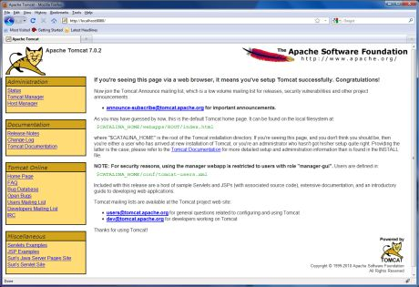
Fig 5.1 Tomcat Web Server

CHAPTER 6

SYSTEM DESIGN AND DEVELOPMENT

6.1 Use Case Diagram

ADMIN
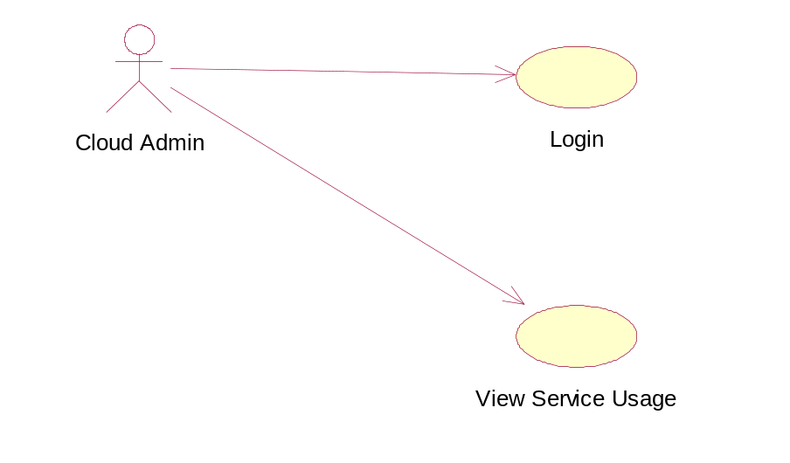
USER
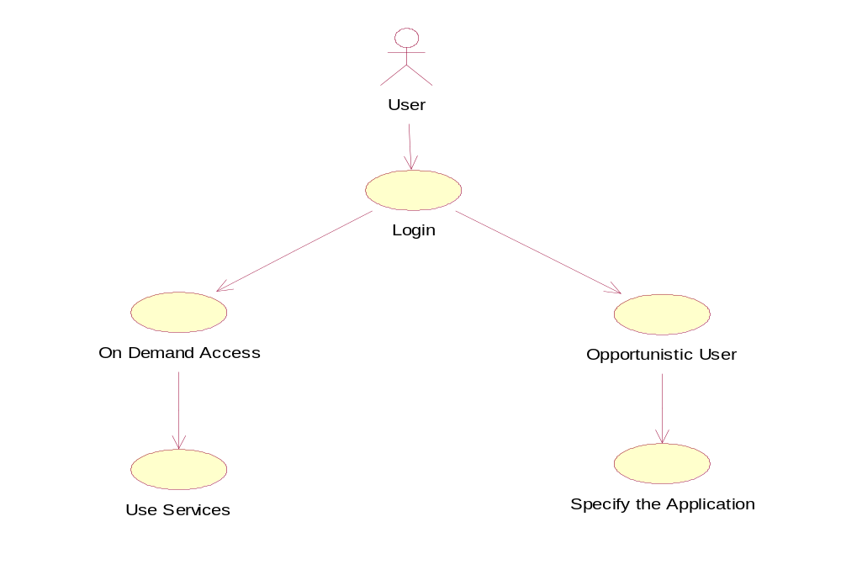
6.2 Class Diagram

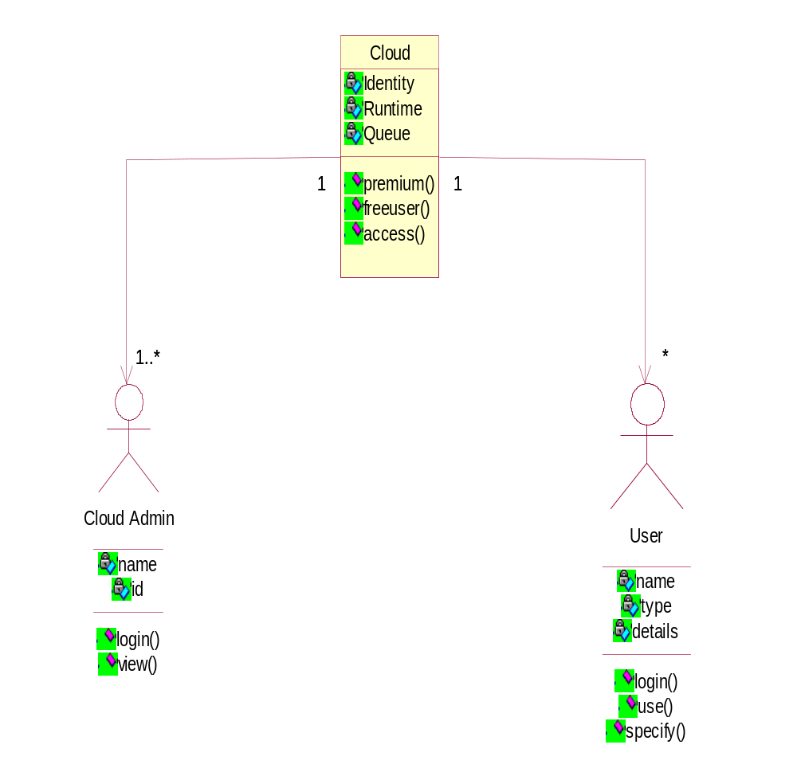

6.3 Sequence Diagram

ADMIN
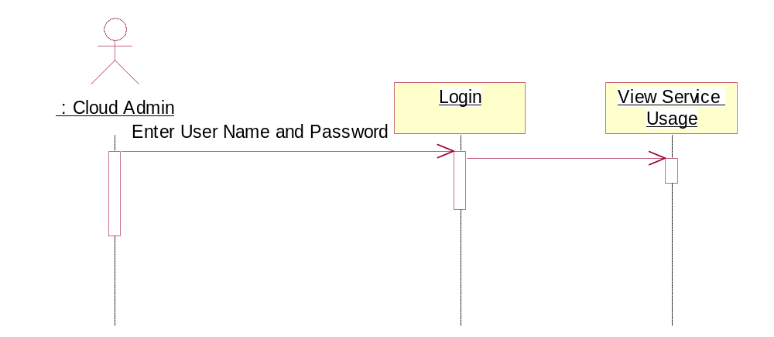

USER
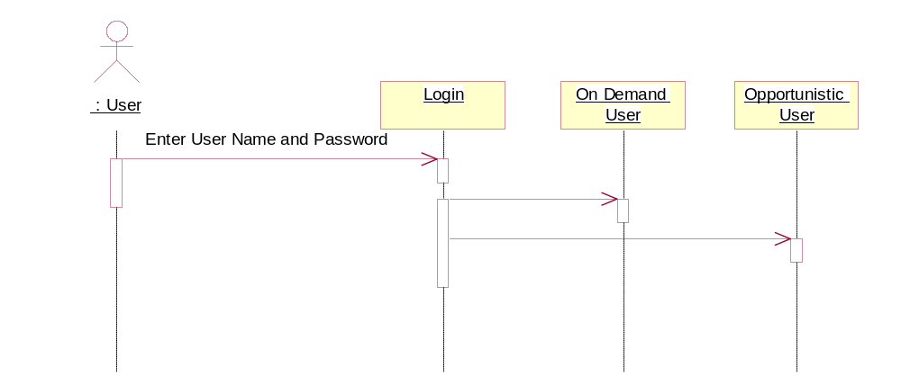

6.4 Activity Diagram

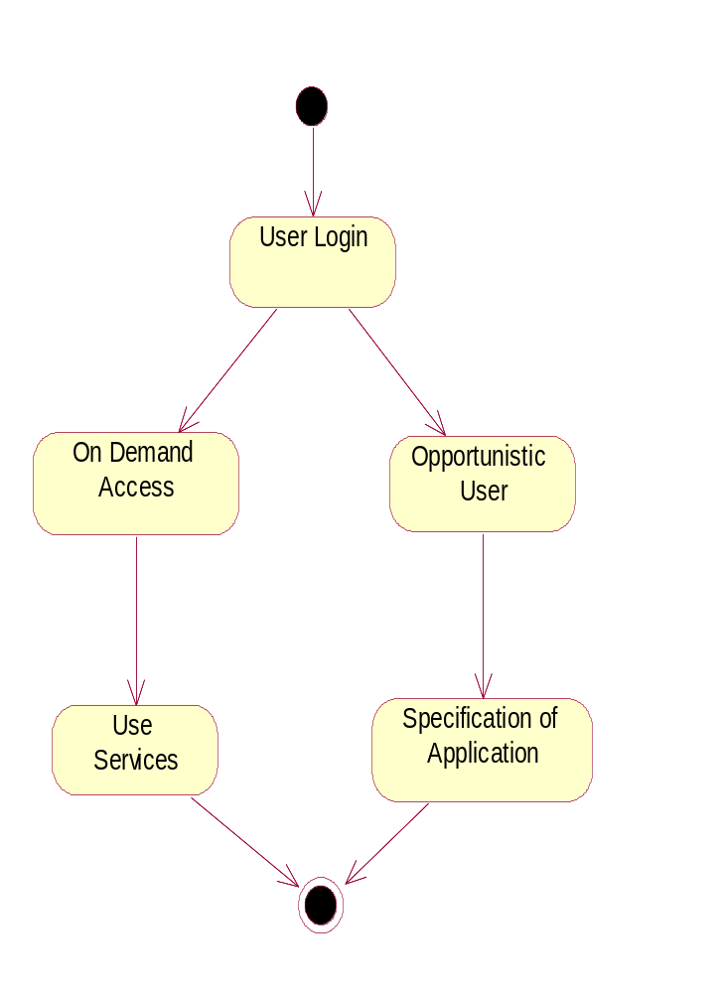

CHAPTER 7

TESTING

7.1 System Testing
Testing is performed to identify errors. It is used for quality assurance. Testing is an integral part of the entire development and maintenance process. The goal of the testing during phase is to verify that the specification has been accurately and completely incorporated into the design, as well as to ensure the correctness of the design itself. For example the design must not have any logic faults in the design is detected before coding commences , otherwise the cost of fixing the faults will be considerably higher as reflected. Detection of design faults can be achieved by means of inspection as well as walkthrough.
Testing is one of the important steps in the software development phase. Testing checks for errors, as a whole of the project testing involves the following test cases:
- Static analysis is used to investigate the structural properties of the Source code.
- Dynamic testing is used to investigate the behavior of the source code by executing the program on the test data.
7.2 Unit Testing
Unit Testing is conducted to verify the functional performance of each modular component of the software. Unit testing focuses on the smallest unit of the software design ( i.e.), the module. The white-box testing techniques were heavily employed for unit testing. In this testing we test each module individually. Unit testing focuses on the verification of the smallest units of the software design of the module. This is known as unit testing. The modules of the system are tested separately. This test is carried out during programming stage itself.
7.3 Functional Testing
Functional test cases involved exercising the code with nominal input values for which the expected results are known, as well as boundary values and special values , such as logically related inputs, files of identical elements, and empty files.

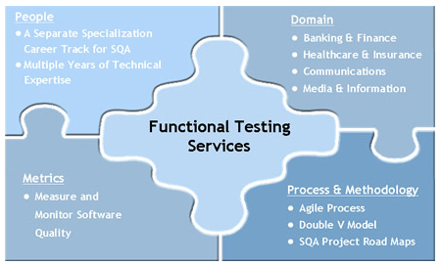
Fig 7.1 Functional Testing
Three types of tests in Functional test:
- Performance Test
- Stress Test
- Structure Test
7.3.1 Performance Test
It determines the amount of execution time spent in various parts of the unit , program throughput and response time and device utilization by the program unit.
7.3.2 Stress Test
Stress Test is those test designed to intentionally break the unit. A Great deal can be learned about the strength and limitations of a program by examining the manner in which a programmer in which a program unit breaks.
7.3.3 Structured Test
Structure Tests are concerned with exercising the internal logic of a program and traversing particular execution paths. The way in which White-Box test strategy was employed to ensure that the test cases could guarantee that all independent paths within a module have been exercised at least once.

7.4 Integration testing
Integration tests are designed to test integrated software components to determine if they actually run as one program. Testing is event driven and is more concerned with the basic outcome of screens or fields. Integration tests demonstrate that although the components were individually satisfaction, as shown by successfully unit testing, the combination of components is correct and consistent. Integration testing is specifically aimed at exposing the problems that arise from the combination of components.

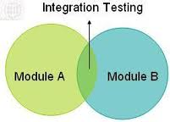
Fig 7.2 Integration Testing

7.5 White Box Testing
White Box Testing is a testing in which in which the software tester has knowledge of the inner workings, structure and language of the software, or at least its purpose. It is purpose. It is used to test areas that cannot be reached from a black box level.
Basis path testing:
- Flow graph notation
- Cyclometric complexity
- Deriving test cases
- Graph matrices Control

7.6 Black Box Testing
Black Box Testing is testing the software without any knowledge of the inner workings, structure or language of the module being tested. Black box tests, as most other kinds of tests, must be written from a definitive source document, such as specification or requirements document, such as specification or requirements document. It is a testing in which the software under test is treated, as a black box .you cannot “see” into it. The test provides inputs and responds to outputs without considering how the software works.
The steps involved in black box test case design are:
- Graph based testing methods
- Equivalence partitioning
- Boundary value analysis
- Comparison testing

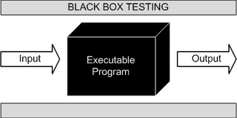
Fig 7.3 Black Box Testing

CHAPTER 8

CODING AND IMPLEMENTATION

ON DEMAND ACCESS :

Company Registration.jsp

<%@ page import="java.sql.*,databaseconnection.*"%>
<html>
<head>
<title>Service</title>
<meta http-equiv="Content-Type" content="text/html; charset=iso-8859-1">
<meta name="Description" content="..." />
<meta name="Keywords" content="..." />
<meta name="robots" content="all,follow" />
<meta name="author" content="..." />

<!-- Javascript -->
<meta http-equiv="Content-Script-Type" content="text/javascript" />

<!-- CSS -->
<link href="default.css" rel="stylesheet" type="text/css" />
<link href="login-box.css" rel="stylesheet" type="text/css" />

<!-- Favicon -->
<link rel="shortcut icon" href="favicon.ico" type="image/x-icon" />
<script language="JavaScript">
function fu()
{

//var a = document.LoginForm.id.value;
var b = document.LoginForm.cname.value;
///var c = document.LoginForm.utype.value;
var d = document.LoginForm.pass.value;
var e = document.LoginForm.email.value;

/*if(a=="")
{
alert("Enter ID");
document.LoginForm.id.focus();
return false;
}*/

if(b=="")
{
alert("Enter Company Name");
document.LoginForm.cname.focus();
return false;
}
if(e=="")
{
alert("Enter E-MailId");
document.LoginForm.email.focus();
return false;
}
var emailfilter=/^\w+[\+\.\w-]*@([\w-]+\.)*\w+[\w-]*\.([a-z]{2,4}|\d+)$/i
var k=emailfilter.test(e);
if(k==false)
{
alert("Please enter a valid mail Id");
document.LoginForm.email.focus();
return false;
}

if(d=="")
{
alert("Enter Password");
document.LoginForm.pass.focus();
return false;
}
if(d.length<5) {
alert("Password should have Five Characters");
document.LoginForm.pass.focus();
document.LoginForm.pass.value="";
return false;
}

if(document.LoginForm.utype.selectedIndex==0)
{
alert("Select UserType");
document.LoginForm.utype.focus();
return false;
}

}
</script>
</head>

<body>
<form name="LoginForm" action="companyreginsert.jsp" method="post" onSubmit="return fu();">
<%
int n=0,s=0;
Connection con=null;
Statement st=null;
ResultSet rs=null;
String sql="select max(id) from reg";
try
{
con=databasecon.getconnection();
st=con.createStatement();
rs=st.executeQuery(sql);
if(rs.next())
{
if(rs.getInt(1)==0)
n=1;
else
n=rs.getInt(1)+1;
session.setAttribute( "id", n );
}
//out.print(n);

%>
<table width="710" border="0" align="center" cellpadding="0" cellspacing="0">
<tr>
<td><img src="images/img2.jpg" alt="" width="710" height="227" /></td>
</tr>
<tr>

<td height="128" style="height: 45px; background: url(images/img1.jpg);">
<table width="670" border="0" align="center" cellpadding="0" cellspacing="0">
<tr>
<td></td><td align="center" width="537"><p><strong><font size="+1"> <font color="#CCCCFF" size="4">&nbsp;IMPROVING
UTILIZATION OF INFRASTRUCTURE CLOUDS</font></font></strong></p>
<p> <strong><font size="+1"><font color="#CCCCFF" size="5"></font></font></strong></p></td>

<td></td>
</tr>
</table></td>
</tr>
</table>
<table ><tr ><td width="150"></td>&nbsp;&nbsp;<td width="120"></td><td width="421" align="center">
<div align="center" id="login-box">
<H2><font color="#66CCFF" size="4"> CREATE ACCOUNT </font></H2>
<div>&nbsp;</div><div>&nbsp;</div><div><table>
<tr>
<td><strong><font size="2">ID</font></strong></td>
<td>:</td><td><input style="background-color: #000000;font: bold 12px Arial" name="id" value="<%=n%>" type="textbox" disabled="true" ></td></tr>
<tr><td>&nbsp;</td></tr>
<tr>
<td><strong><font size="2">Company Name</font></strong></td>
<td>:</td><td><input style="background-color: #000000;font: bold 12px Arial" name="cname" type="text"></td></tr>
<tr><td>&nbsp;</td></tr>
<tr>
<td><strong><font size="2">EmailID</font></strong></td>
<td>:</td><td><input style="background-color: #000000;font: bold 12px Arial" name="email" type="text"></td></tr>
<tr><td>&nbsp;</td></tr>
<tr>
<td><strong><font size="2">Password</font></strong></td>
<td>:</td><td><input style="background-color: #000000;font: bold 12px Arial" name="pass" type="password"></td></tr>
<tr><td>&nbsp;</td></tr>
<tr>
<td><strong><font size="2">User Type</font></strong></td>
<td>:</td>
<td><select style="background-color: #52555C ;height: 25px; width: 120px;font: bold 12px Arial" name="utype"><option value="select">--Select--</option><option value="On Demand">On Demand</option><option value="Opportunistic">Opportunistic</option></select></td>
</tr>
<tr><td>&nbsp;</td></tr>
<tr><td><input name="login" type="submit" style="background-color: #52555C ;height: 25px; width: 100px;font: bold 14px Arial" value="Submit">
</td>
<td></td>
<td> <input name="clr" type="reset" style="background-color: #52555C ;height: 25px; width: 100px;font: bold 14px Arial" value="Clear">
</td></tr>
</table></div>
<div>
</div>
<div></div><div></div></p>
<strong></strong> </div>
</div></td><td width="148"></td><td width="76"></td></tr></table>
<table width="710" border="0" align="center" cellpadding="0" cellspacing="0">
<tr>
<td align="center"><img src="images/spacer.gif" alt="" width="50" height="30" /></td>
</tr>
<tr>
<td class="text1" style="height: 45px; background: url(images/img1.jpg);"></td>
</tr>
</table>
<%
}
catch(Exception e)
{
System.out.println(e);
}
finally
{
con.close();
st.close();
}
%>
</form>
</body>
</html>

OPPORTUNISTIC USER:

Distributor.jsp

<%@ page contentType="text/html; charset=" language="java" import="java.sql.*" errorPage="" %>
<%@ page import="databaseconnection.*"%>
<html>
<head>
<title>Distributor Home Page</title>
<meta http-equiv="Content-Type" content="text/html; charset=utf-8" />
<title>Your website name | Homepage</title>
<!-- This template was created by Mantis-a [http://www.mantisa.cz/]. For more templates visit Free website templates [http://www.mantisatemplates.com/]. -->
<meta name="Description" content="..." />
<meta name="Keywords" content="..." />
<meta name="robots" content="all,follow" />
<meta name="author" content="..." />
<!-- Javascript -->
<meta http-equiv="Content-Script-Type" content="text/javascript" />
<!-- CSS -->
<link rel="stylesheet" href="css/style.css" type="text/css" media="screen, projection, tv" />
<link rel="stylesheet" href="css/style-print.css" type="text/css" media="print" />
<!-- Favicon -->
<link rel="shortcut icon" href="favicon.ico" type="image/x-icon" />
</head>
<body>
<form name="form" action="" method="post" >
<%
Connection con=null;
Statement st=null;
ResultSet rs=null;
String sql="select max(id) from register ";
try
{
con=databasecon.getconnection();
st=con.createStatement();
rs=st.executeQuery(sql);
//session.setAttribute( "id", n );

%>
<div id="wrapper">
<!-- Header -->
<div id="header">
<!-- Your website name -->
<h1><font color="#FFFFFF">
<marquee direction="right">
FRAUD DETECTION SERVICE
</marquee>
</font></h1>
<!-- Your website name end -->
<!-- Your slogan -->
<h2></h2>
<!-- Your slogan end -->
<div id="header-arrow"></div>
</div>
<!-- Header end -->
<!-- Menu -->
<a href="#skip-menu" class="hidden">Skip menu</a>
<ul id="menu" class="cleaning-box">
<li class="first"><a href="distributorhome.jsp" class="active">HOME</a></li>
<li><a href="distributorsend.jsp">Send Files</a></li>
<li><a href="distributorviewfiles .jsp">View Files</a></li>
<li><a href="distributorleakfiles.jsp">Leak Files</a></li>
<li><a href="index.html">LogOut</a></li>
</ul>
<!-- Menu end -->
<hr class="noscreen" />
<div id="content-box">
<div id="content-box-in">
<!-- Content left -->
<div class="content-box-left">
<div class="content-box-left-in">
<h1>DISTRIBUTOR</h1>
</div>
</div>
<!-- Content left end -->
<hr class="noscreen" />
<!-- Content right -->
<div class="content-box-right">
<h4>Welcome Distributor !</h4>
<div class="content-box-right-in">
<dl>
<dt><br />
<a href="#"><img src="img/dr.jpg" width="120" height="90" " /></a>
</dt>
</dl>
</div>
<div class="content-box-right-in"></div>
<div id="column-right-bottom">&nbsp;</div>
</div>
<!-- Content right end -->
<div class="cleaner">&nbsp;</div>
</div>
</div>
<hr class="noscreen" />
<!-- Footer -->
<!-- Footer end -->
</div>
<%
}
catch(Exception e)
{
System.out.println(e);
}
finally
{
con.close();
st.close();
}

%>
</form>
</body>
</html>

BACKFILL DEPLOYMENT :

Document.jsp

<%@ page language="java" import="java.io.*,java.sql.*" %>
<!DOCTYPE HTML PUBLIC "-//W3C//DTD HTML 4.01 Transitional//EN"
"http://www.w3.org/TR/html4/loose.dtd">
<html>
<head>
<meta http-equiv="Content-Type" content="text/html; charset=iso-8859-1">
<script language="JavaScript" type="text/JavaScript">
<!--
function MM_reloadPage(init) { //reloads the window if Nav4 resized
if (init==true) with (navigator) {if ((appName=="Netscape")&&(parseInt(appVersion)==4)) {
document.MM_pgW=innerWidth; document.MM_pgH=innerHeight; onresize=MM_reloadPage; }}
else if (innerWidth!=document.MM_pgW || innerHeight!=document.MM_pgH) location.reload();
}
MM_reloadPage(true);
//-->
</script>
<style type="text/css">
<!--
.style4 {
font-size: large;
color: #3300CC;
}
.style6 {
color: #0033FF;
font-weight: bold;
}
.style9 {font-size: 24px}
-->
</style>
</head>
<%
String s=request.getParameter("prcode");
String s1=request.getParameter("gtype");
ResultSet rs;
Statement st;
String m=null;
String n=null;
String z=null;
String a=null;
String b=null;
Connection con=null;
%>
<%
String str="select * from addnew where pro_code='"+s+"'";
try
{
Class.forName("com.mysql.jdbc.Driver");
con = DriverManager.getConnection("jdbc:mysql://localhost:3306/movedb","root","admin");
st=con.createStatement();
rs=st.executeQuery(str);
while(rs.next())
{
n=rs.getString(1);
z=rs.getString(2);
m=rs.getString(7);
}
}
catch(Exception e)
{
}
%>

<%
if(s1.equals("1"))
{
String str1="select * from group1 where pro_code='"+s+"'";
try
{
Class.forName("com.mysql.jdbc.Driver");
con = DriverManager.getConnection("jdbc:mysql://localhost:3306/movedb","root","mani");
st=con.createStatement();
rs=st.executeQuery(str1);
while(rs.next())
{
a=rs.getString(2);
b=rs.getString(9);
}
}
catch(Exception e)
{
if(s1.equals("2"))
{
String str2="select * from group2 where pro_code='"+s+"'";
try
{
Class.forName("com.mysql.jdbc.Driver");
con = DriverManager.getConnection("jdbc:mysql://localhost:3306/movedb","root","madhu");
st=con.createStatement();
rs=st.executeQuery(str2);
while(rs.next())
{
a=rs.getString(2);
b=rs.getString(9);
}
}
catch(Exception e)
{
}
}
%>
<body>
<div id="Layer2" style="position:absolute; left:263px; top:184px; width:301px; height:25px; z-index:2">
<div align="center" class="style4">Documents Creation Form </div>
</div>
<div id="Layer3" style="position:absolute; left:182px; top:250px; width:454px; height:202px; z-index:3">
<form name="form1" method="post" action="taskvalidation.jsp">
<table width="452" border="1">
<tr>
<td width="244"><span class="style6">Enter the Project Code </span></td>
<td width="192"><input type="text" name="prcode" value="<%=z%>"></td>
</tr>
<tr>
<td><span class="style6">Enter the Project Leader Code </span></td>
<td><input type="text" name="plcode" value="<%=m%>"></td>
</tr>
<tr>
<td><span class="style6">Enter the Task No </span></td>
<td><input type="text" name="task" value="<%=b%>"></td>
</tr>
<tr>
<td><span class="style6">Enter the Group Leader code </span></td>
<td><input type="text" name="gtype" value="<%=a%>"></td>
</tr>
<tr>
<td><span class="style6">Enter the no of documents</span></td>
<td><input type="text" name="doc"></td>
</tr>
</table>
<p align="center">
<input type="submit" name="Submit" value="Create">
<input name="Reset" type="reset" id="Reset" value="Reset">
</p>
</form>
</div>
</body>
</html>

IMPLEMENTATION SCREENSHOTS :

HomePage

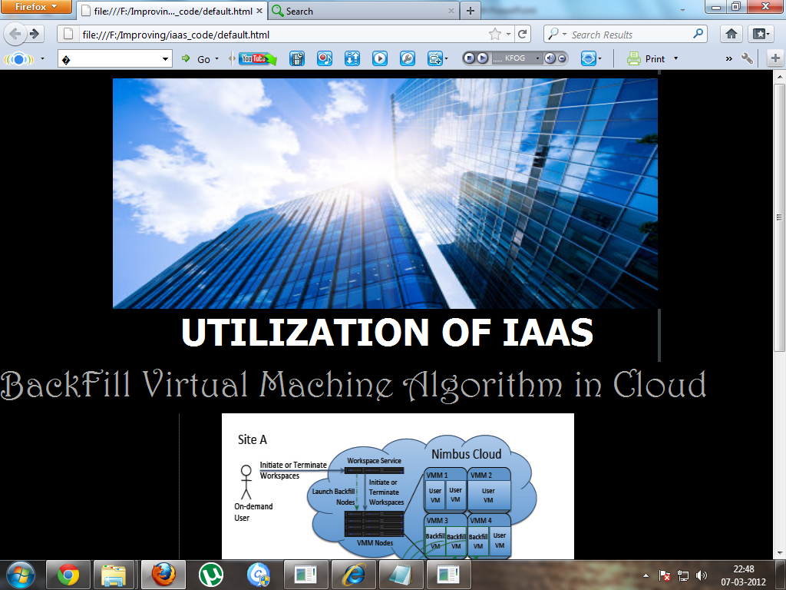

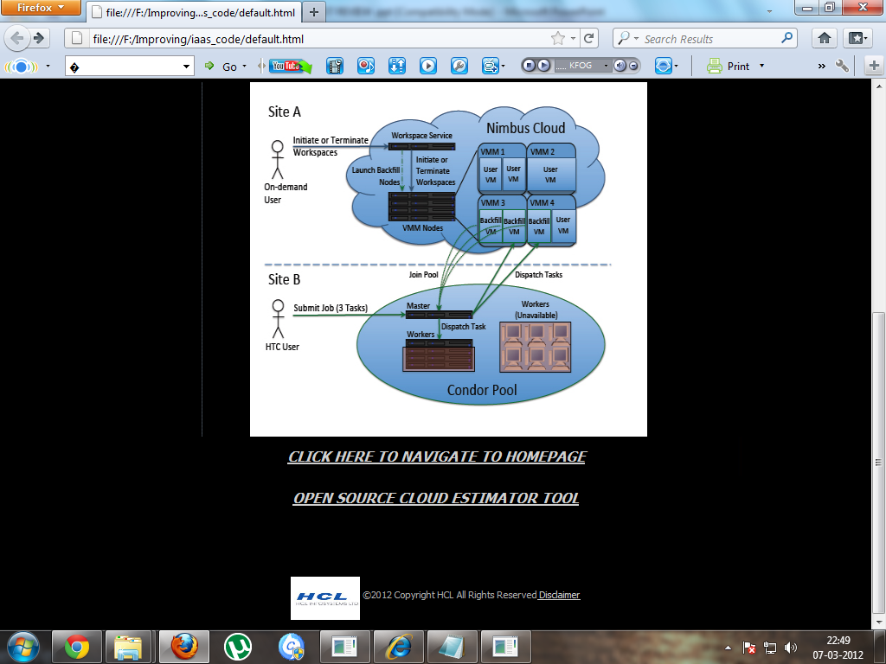

ON DEMAND ACCESS :

Registration

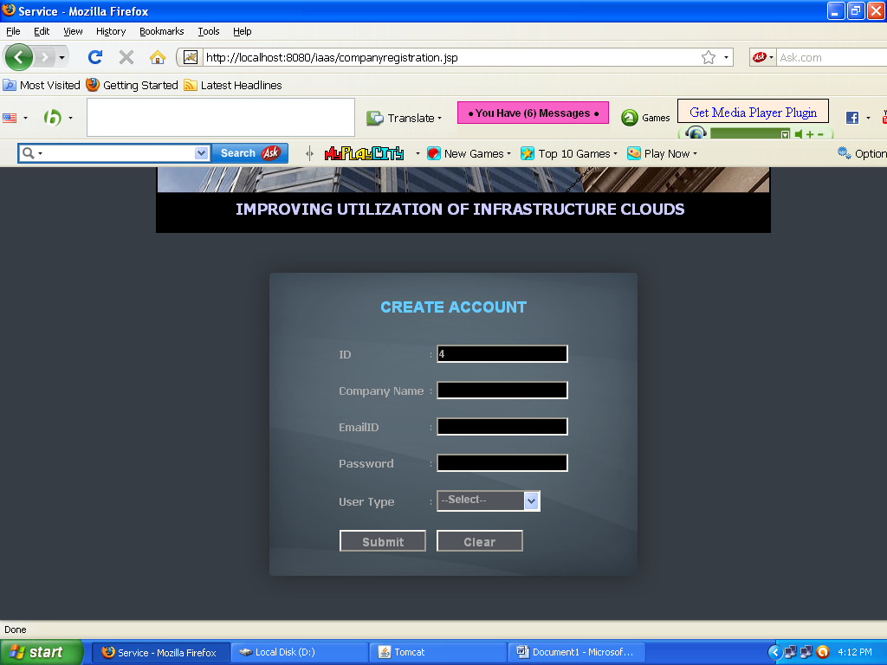
Account Management

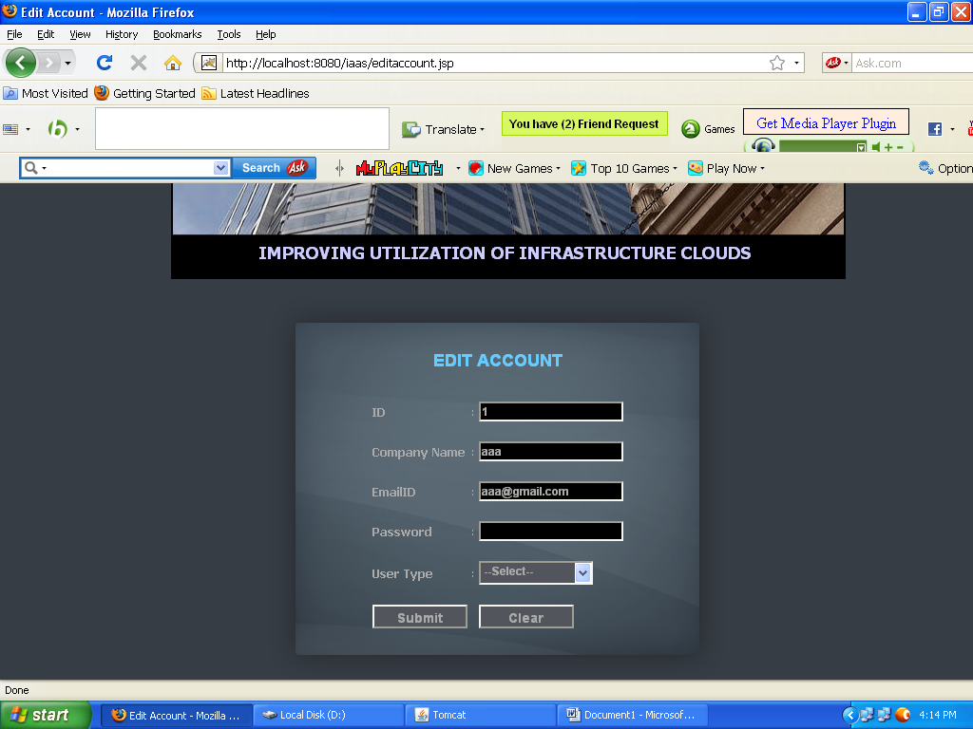

User Access

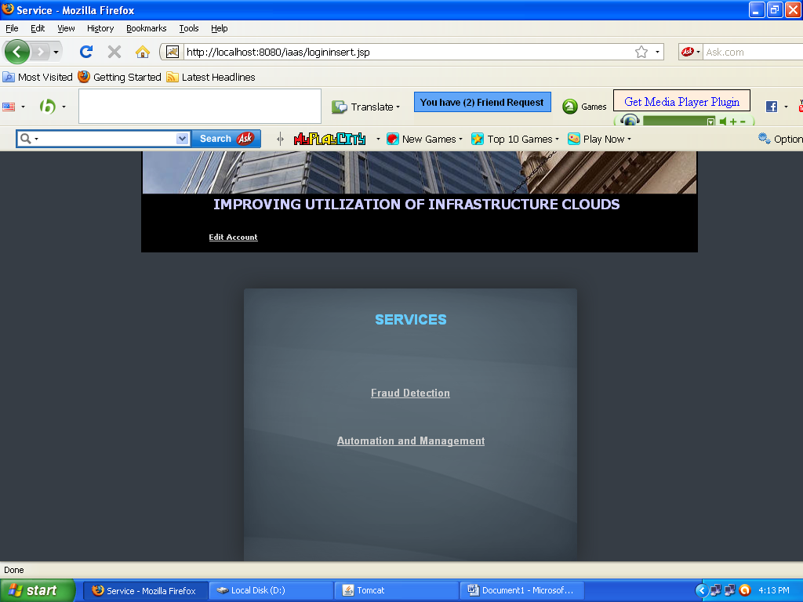
FRAUD DETECTION SERVICE

Application Viewer

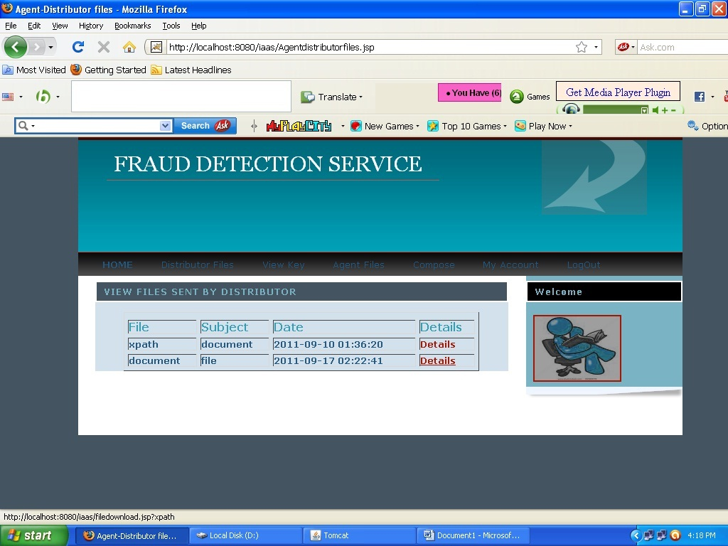

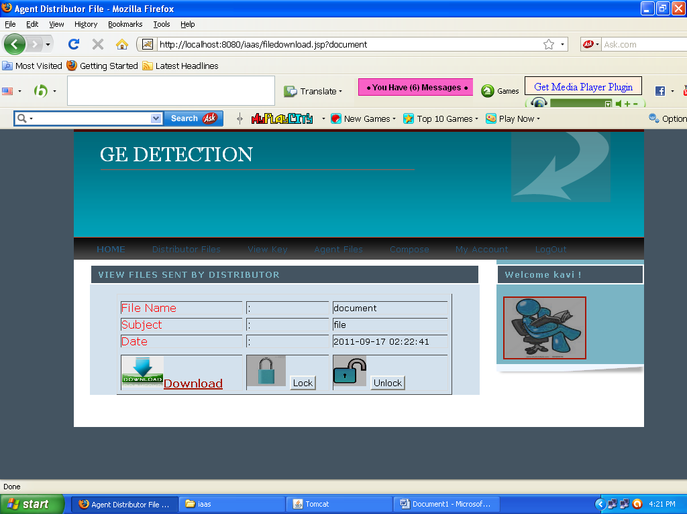

SECURITY CONSTRAINTS

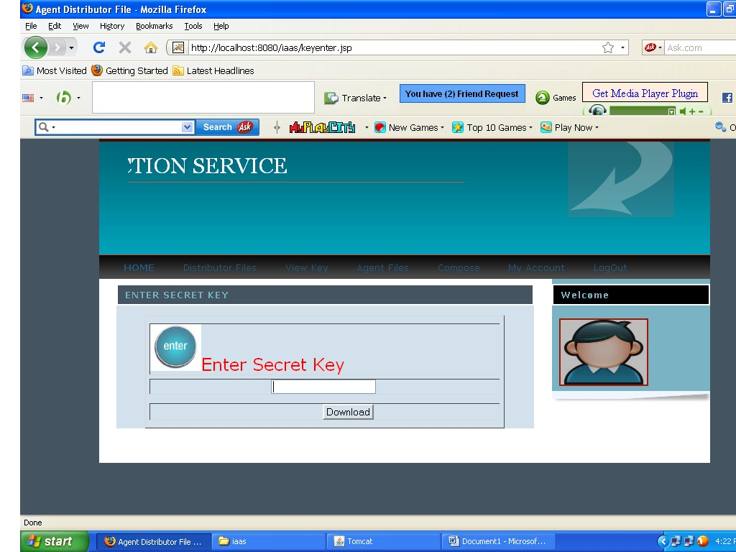

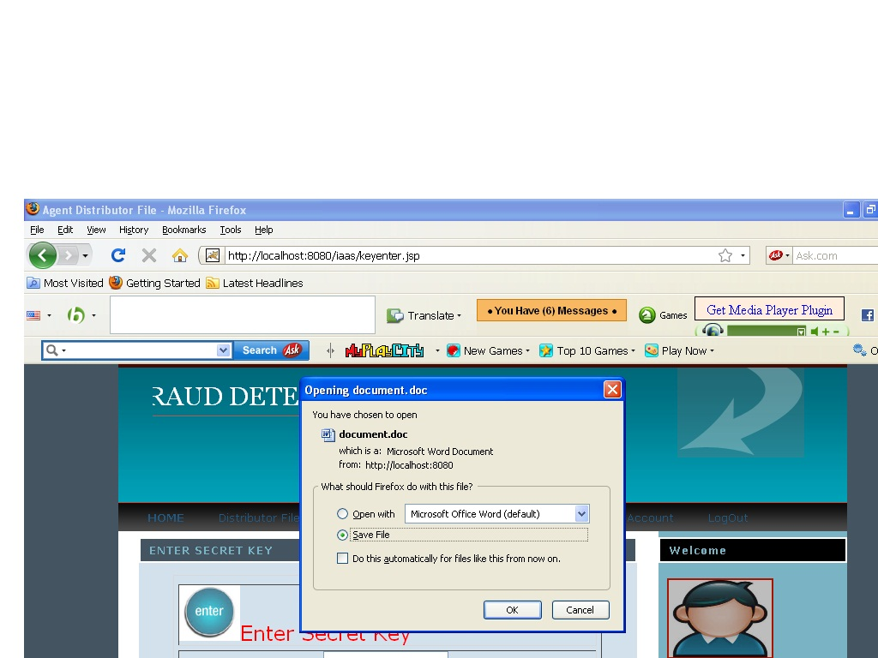

LEAKAGE DETECTION

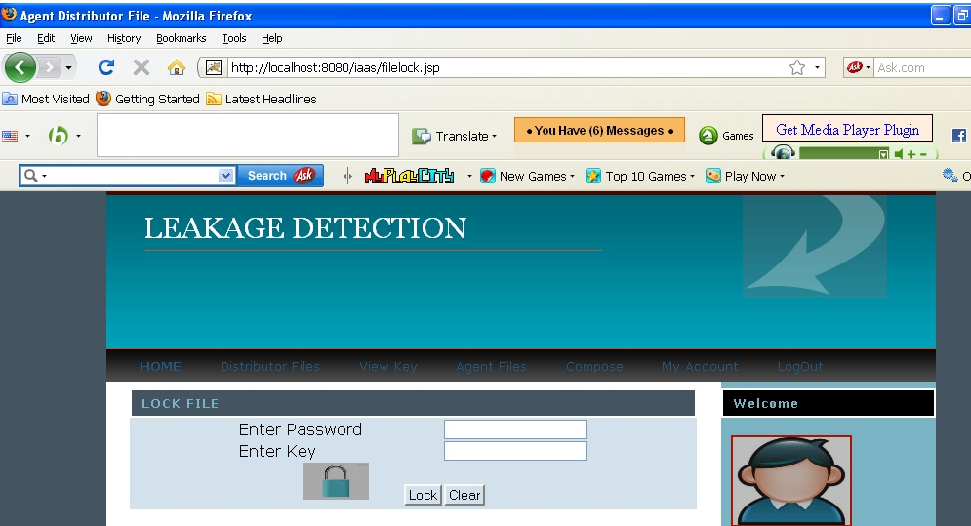

AUTOMATION MANAGEMENT SERVICE

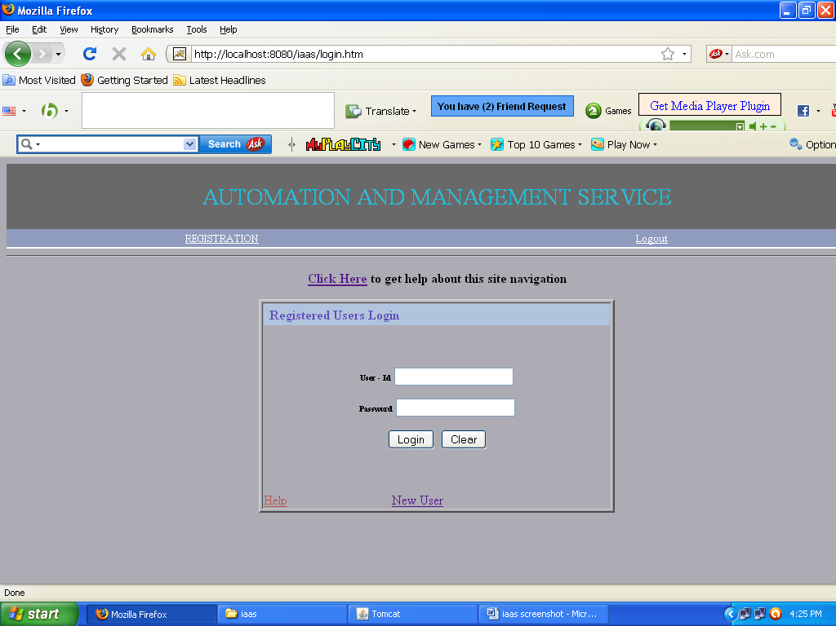

NEW PROJECT

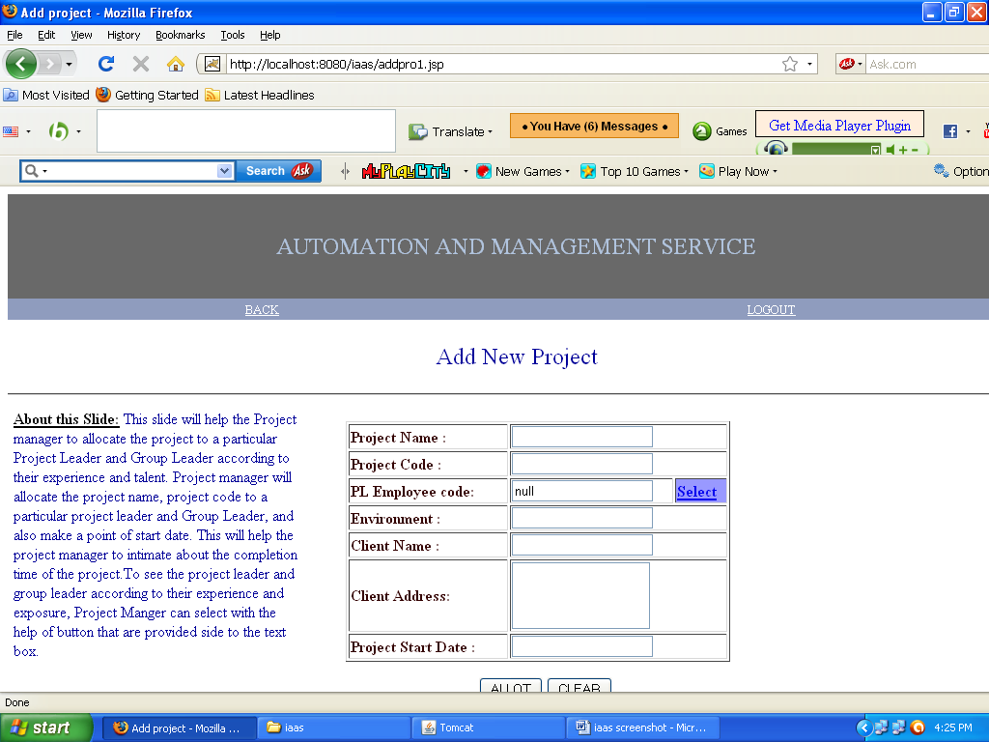

PROJECTS ALLOTMENT

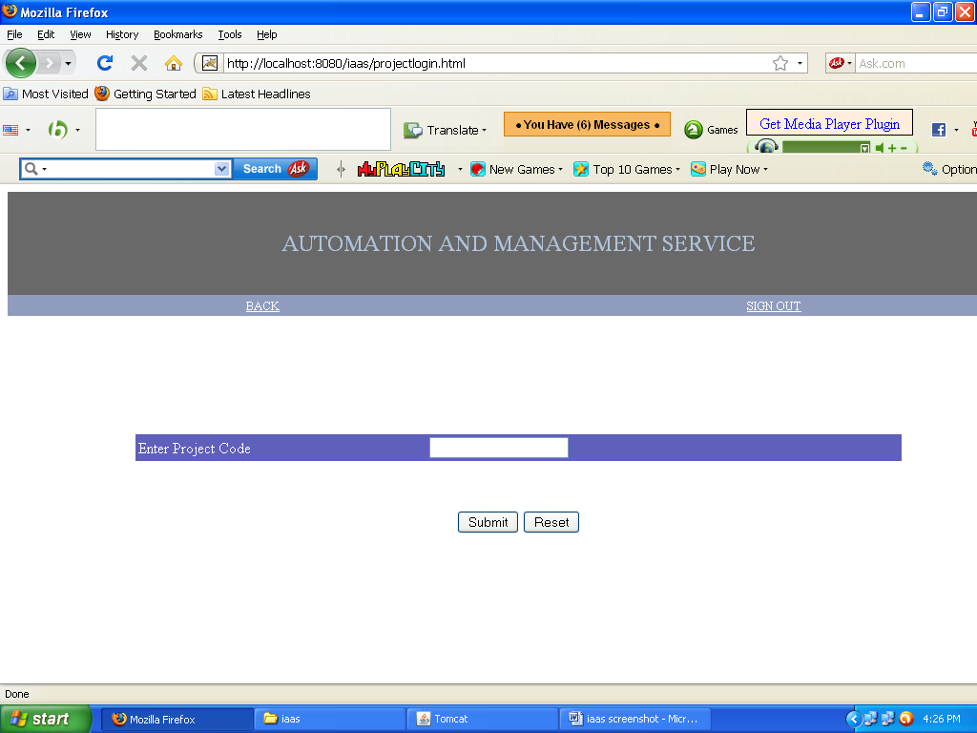

PROJECT UPDATION

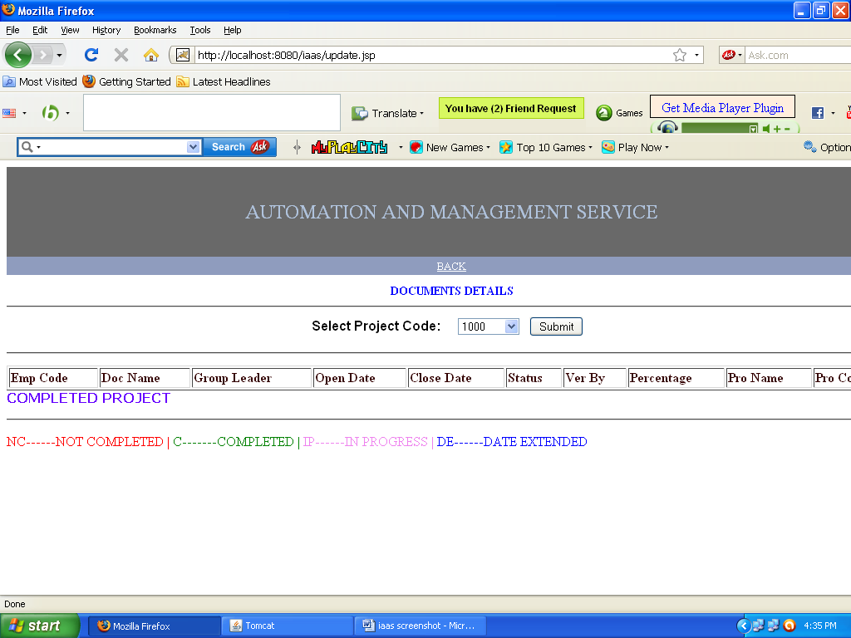

TEAM LEADER MENU

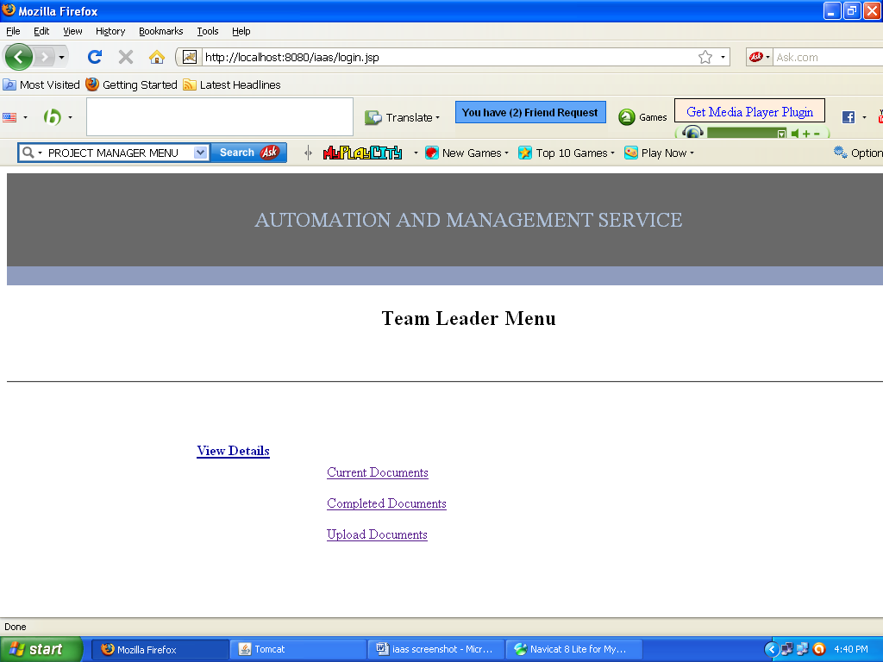

UPLOAD DOCUMENT

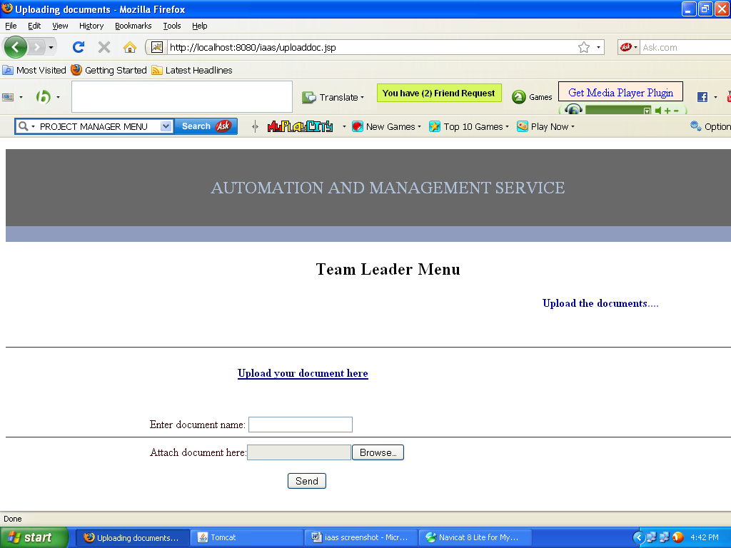

VIEWING SERVICE USAGE

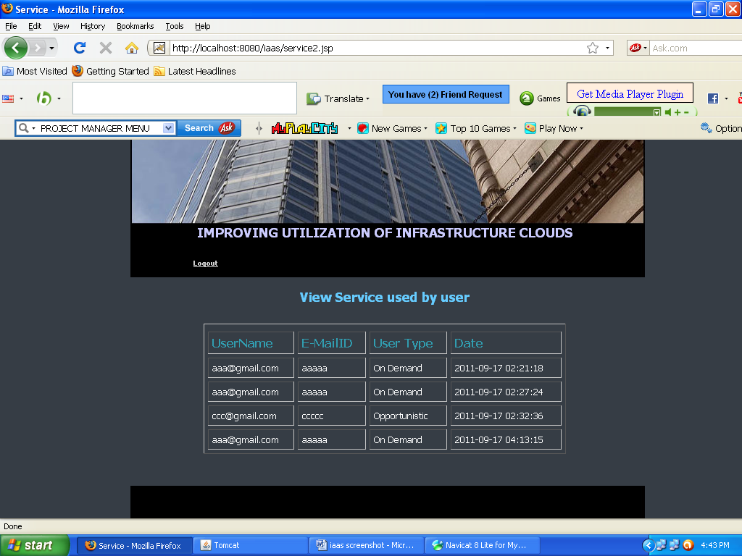
CHAPTER 9

CONCLUSION AND FUTURE ENHANCEMENTS

Conclusion:

We propose a cloud infrastructure that combines on-demand allocation of resources with opportunistic provisioning of cycles from idle cloud nodes to other processes. We demonstrate that a shared infrastructure between IaaS cloud providers and an HTC job management system can be highly beneficial to both the IaaS cloud provider and HTC users by increasing the utilization of the cloud infrastructure (thereby decreasing the overall cost) and contributing cycles that would otherwise be idle to processing HTC jobs.

Future Enhancement:

The backfill implementation used in this paper was an initial prototype created to demonstrate of the usefulness of combining IaaS cloud infrastructure resources with other purposes, such as HTC, through backfill VMs. Therefore, backfill instances are
preemptible by both on-demand requests and spot requests. The future work opens up the opportunity to explore different variants of the policies described in Section II. For
instance, exploring finer granularity with which to deploy VMs, optimizing the backfill image deployment method, as well as termination policies. Another possible area for future work is suspending backfill VMs instead of terminating them.
Such a solution may be ideal for a backfill application that does
not leverage resubmission as its recovery mechanism.

Another set of challenges arises if we broaden the definition of the preemptible lease, e.g., by removing the assumption that only one type of backfill VMs may be used or that only the administrator can configure backfill VMs. One simple refinement would be for the administrator to define multiple backfill VMs and have policies on how backfill resources are shared among them (e.g., what percentage of available cycles should be devoted to each). Additionally, we could also consider different types of leases, e.g., to provide for the impact of backfill VMs on parallel jobs where all processes for a single parallel job must be available.

CHAPTER 10

REFERENCES

- Amazon Web Services. Amazon.com, Inc. [Online]. Retreived December 6, 2010, from: http://www.amazon.com/aws/

- Anderson D and Fedak G. “The Computational and Storage Potential of Volunteer Computing,” CCGRID’06, 2006, p. 73-80.

- Anderson DP, Cobb J, Korpela E, Lebofsky M, Werthimer D.SETI@home: An Experiment in Public-Resource Computing.Communications of the ACM, 45(11), November 2002, 56-61.

- Anderson, D. “BOINC: A System for Public-Resource Computing and Storage,” 5th IEEE/ACM Workshop on Grid Computing, Nov. 2004.

- Douglas Thain, David Cieslak, and Nitesh Chawla, "Condor Log Analyzer", http://condorlog.cse.nd.edu, 2009.

- Feitelson DG, Rudolph L. Parallel job scheduling: Issues and approaches. Lecture Notes in Computer Science: Job Scheduling Strategies for Parallel Processing, 949, 1995.

- Snell Q, Clement M, and Jackson D. Preemption based backfill. In Feitelson, Rudolph, and Schwiegelshohn, editors, Job Scheduling Strategies for Parallel Processing, pages 24–37. Springer Verlag, 2002.Lect. Notes Comput. Sci. vol. 2537.

